**MBO OPERATIONAL MANUAL FOR EMPLOYEES FY2017 – FAQ**

**1/ Cannot login** [**https://renesas.ehr.com/**](https://renesas.ehr.com/)

* Login ID: company email address
* Password :

+ Employee who has been transferred to SingleDomain(＠renesas.com): Office365 password

+ Employee who has not been transferred to SingleDomain(＠renesas.com): DS password

(For initializing of DS password, please go to the link:http://rdp8a01.edc.renesas.com/xa00/password/pwdInit_renesas.jsp?language=en)

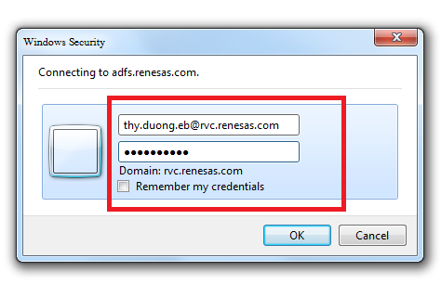

For detail, please read page 11 of MBO Operational Manual for Employees

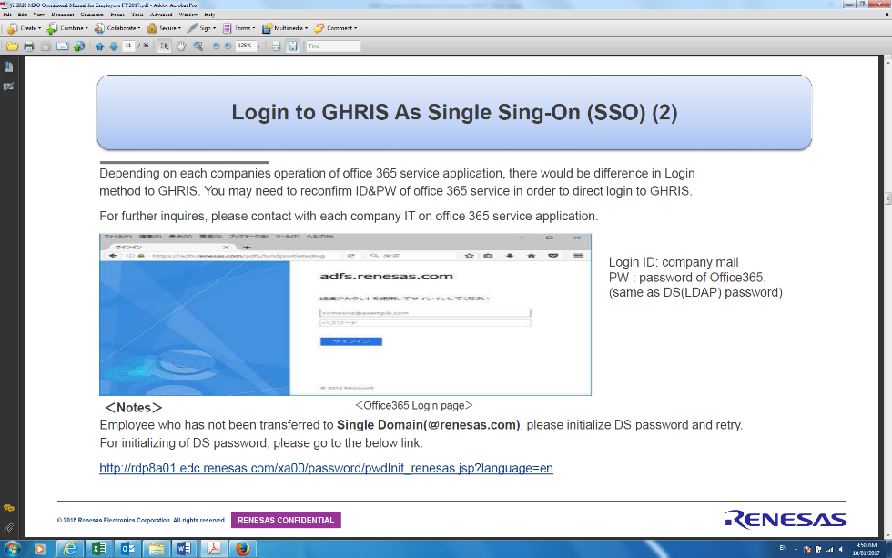

**2/ Cannot input your MBO objectives or load GHRIS page**

If you can’t input your MBO objectives or load GHRIS page please check the version of your web browser.

If your version is older than ones listed below then please contact IT though helpdesk. We will support you to upgrade your browser.

*Microsoft Internet Explorer 9/10/11 (recommended)*

**3/ How to set Objectives**

1. Key points on Setting Objectives: please read pages 7 of MBO Operational Manual for Employees:

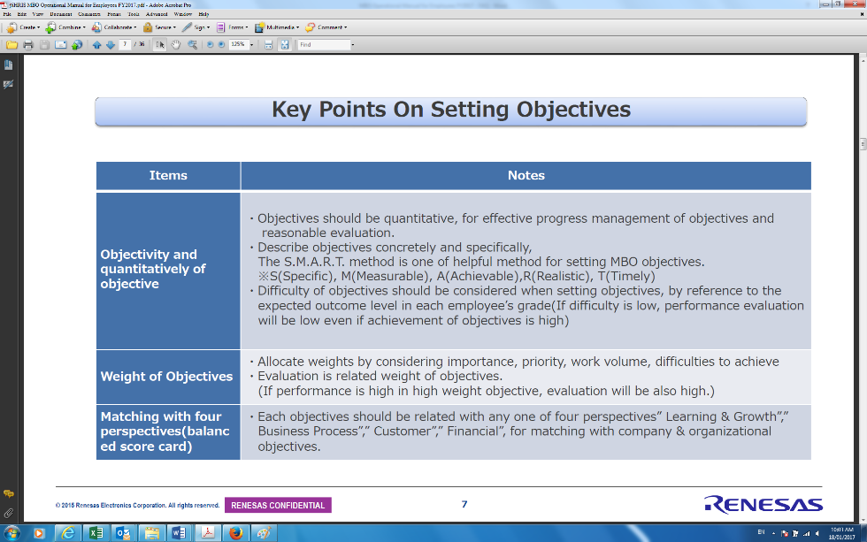

1. Setting Objectives on HRIS: please read pages 7 of MBO Operational Manual for Employees:

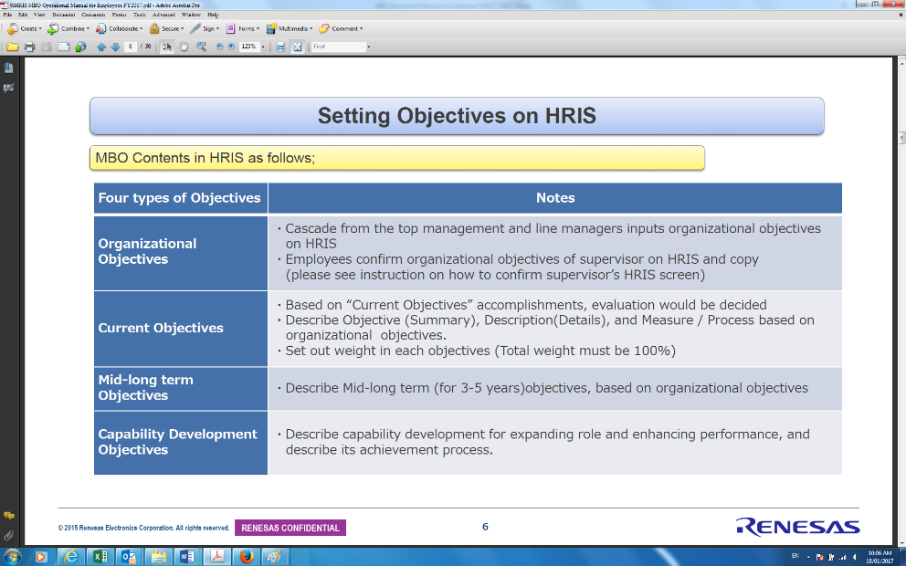

MBO content in HRIS as follows: four types of objectives

* **Organizational Objectives:**

|  |
| --- |
| * Cascade from the top management and line managers inputs organizational objectives on HRIS * Employees confirm organizational objectives of supervisor on HRIS and copy (please see instruction on how to confirm supervisor’s HRIS screen)   ***Setting up “Organizational Objectives”***  ①Click on ‘Add Objectives’ and describe organizational Objective  **②It is not necessary to Input In ‘Description’ and ‘Measure / Process’**  ※SLM inputs “Organizational Objectives”, employee copies Objectives of SLM (Refer next page about method of confirmation).  ③Select ‘Viewable by Solid Line Managers and Direct Reports of ●●●●’  ※After setting this function, employee can confirm “Organizational Objectives”.  ④Click on ‘Save’. ⑤**You don‘t have to set weight**  Please read page 22 of MBO Operational Manual for Employees |

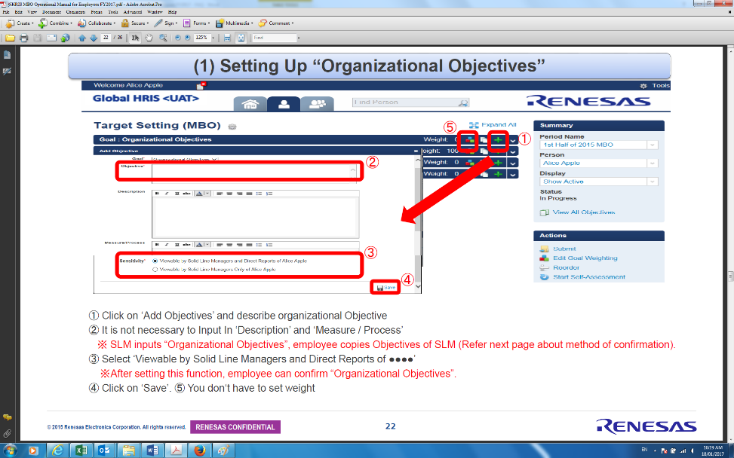

***How to confirm SLM`s “Organizational Objectives”?***

Please read page 23, 24 of MBO Operational Manual for Employees

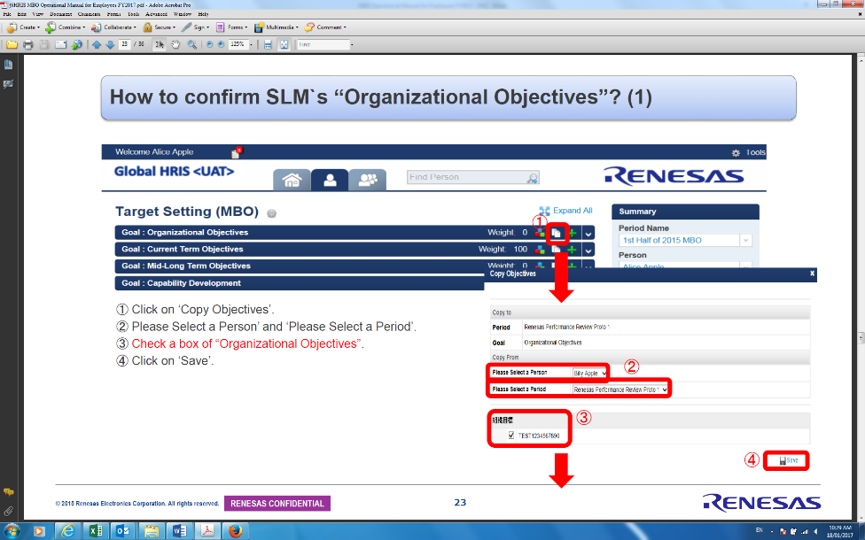

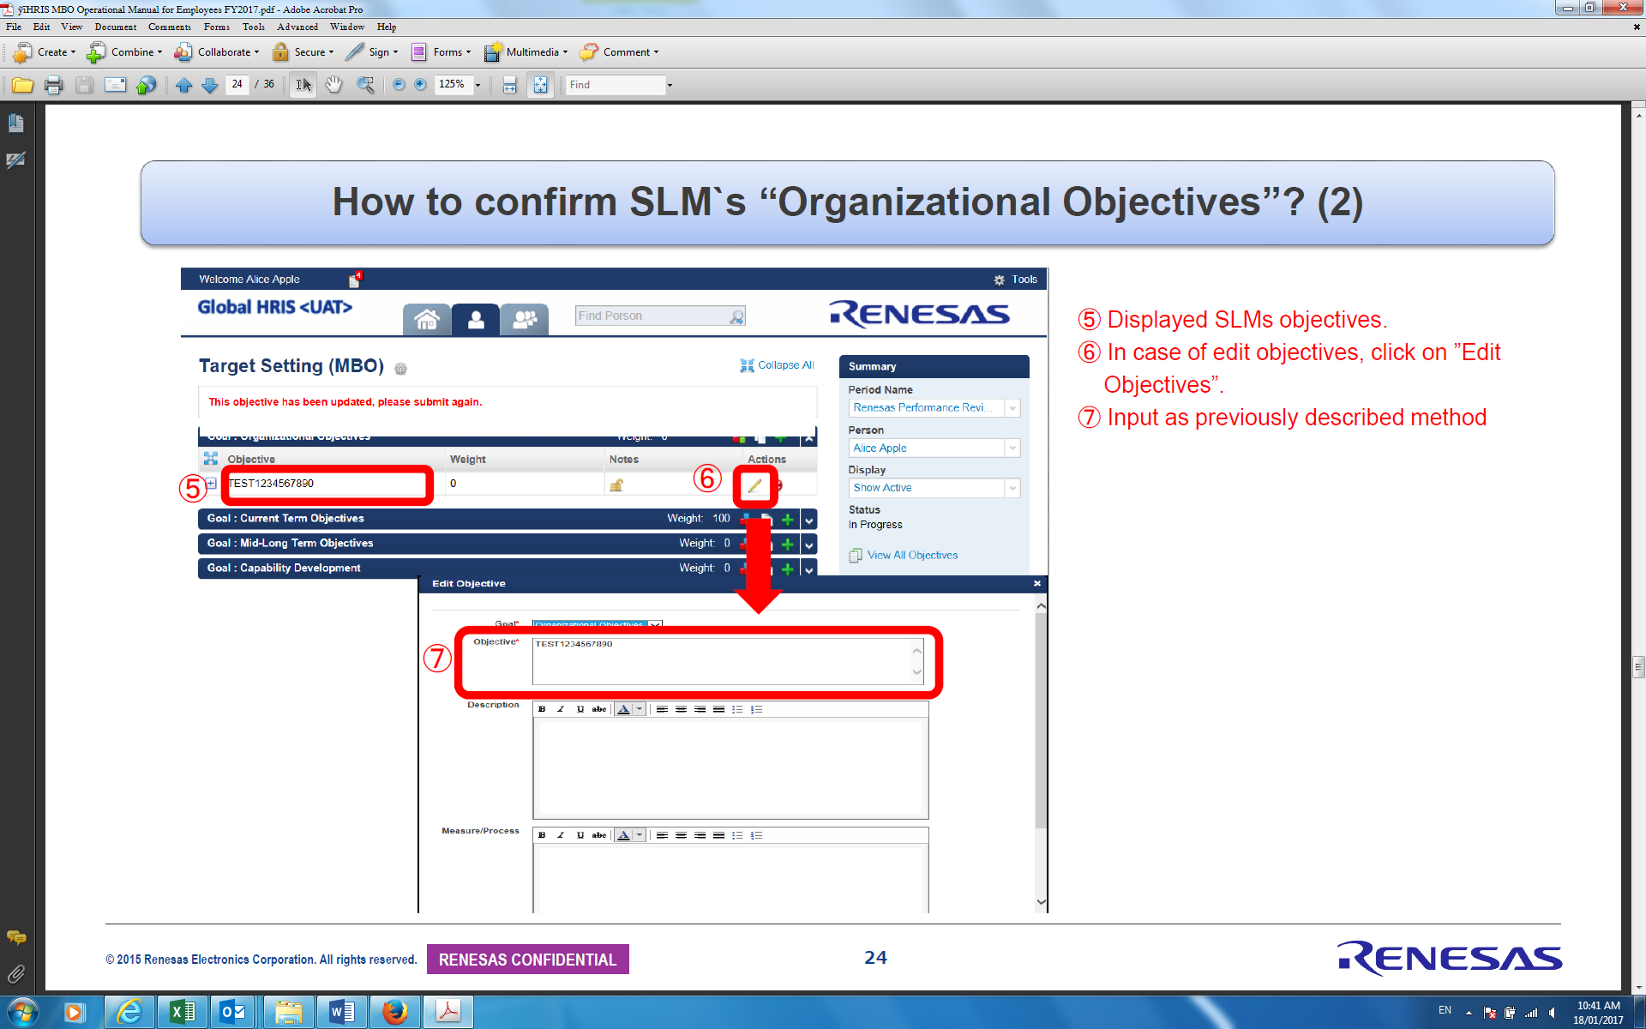

* **Current Objectives:**

|  |
| --- |
| * Based on “Current Objectives” accomplishments, evaluation would be decided * Describe Objective (Summary), Description (Details), and Measure / Process based on organizational objectives. * Set out weight in each objectives **(Total weight must be 100%)**   ***Setting up “Current Objectives”*** |

①Click on ‘Add Objectives’.

②Input ‘Objective (summary), Description (details) and ‘Measure/ Process’.

※Objectives should be related with four perspectives (consists: financial issues, customer related, business process, and

Learning & growth)

③Keep it as it is ‘Sensitivity’

④Click on ‘Save’.

⑤Click on ‘Edit Objectives Weight’ to set weight.

⑥Weight of objectives should be 100% in total.

**※”Distribute Evenly (make sure it becomes 100%)**

⑦Click on ‘Save’.

Please read page 25, 26 of MBO Operational Manual for Employees

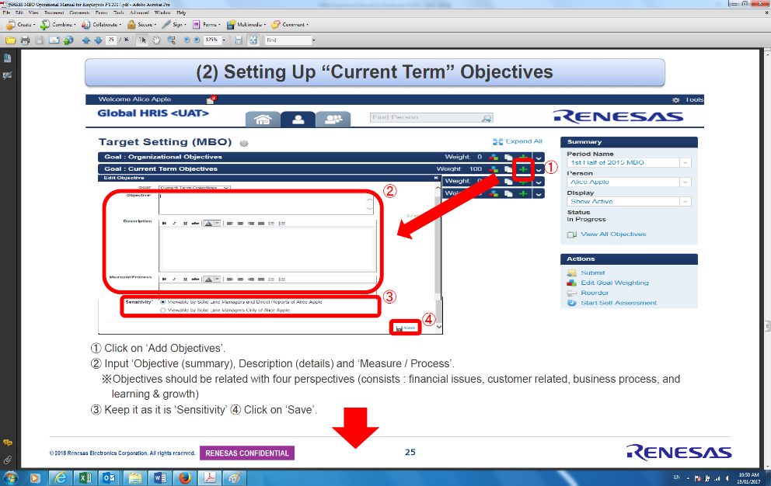

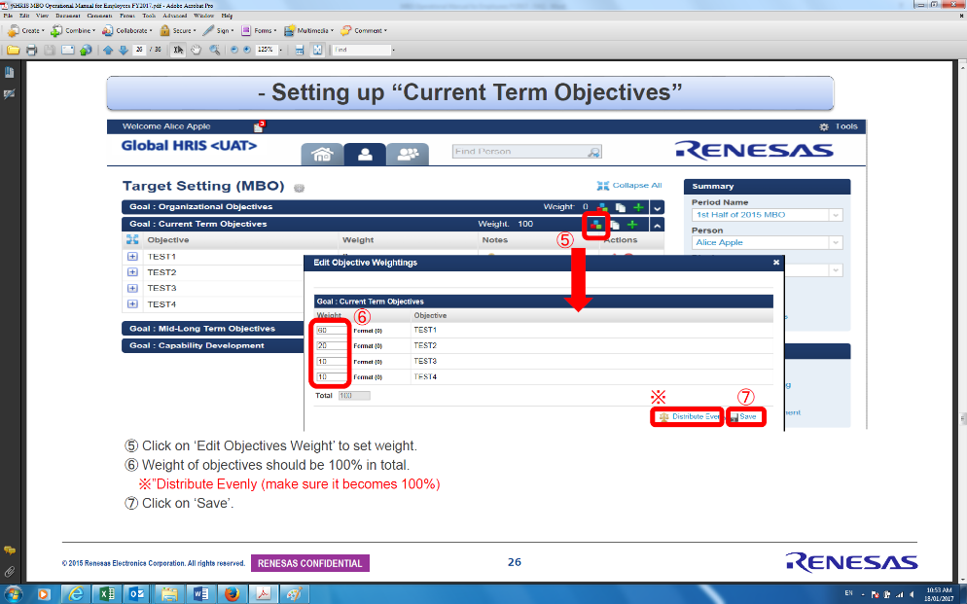

* **Mid-Long Term Objectives:**

|  |
| --- |
| * Describe Mid-long term (for 3-5 years) objectives, based on organizational objectives |

***Setting up “Mid-Long Term Objectives”***

①Click on ‘Add Objectives’

②Input ‘objective （Summary, Description （Details and ‘Measure / Process’.

③Keep it as it is ‘Sensitivity’.

④Click on ‘Save’.

**⑤You don‘t have to set weight**

Please read page 27 of MBO Operational Manual for Employees

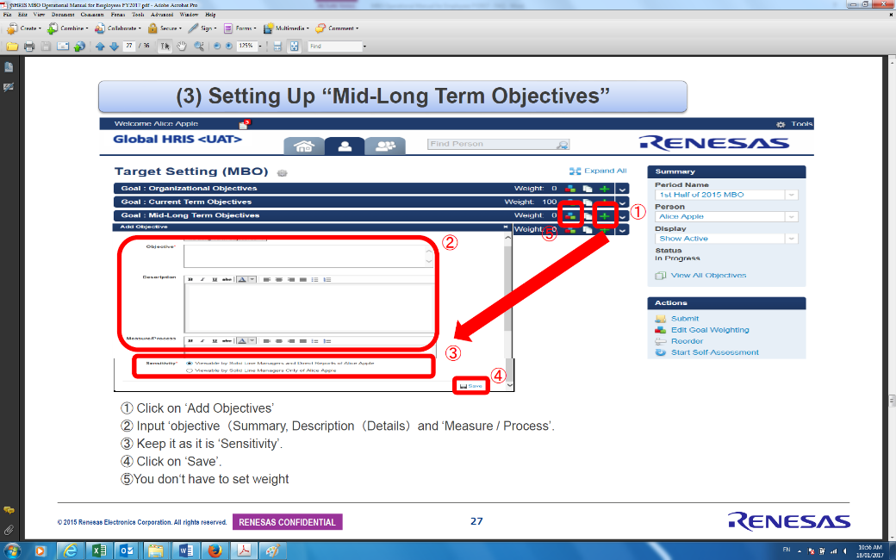

|  |
| --- |
| * **Capability Development Objectives:** * Describe capability development for expanding role and enhancing performance, and describe its achievement process. |

***Setting up “Mid-Long Term Objectives”***

①Click on ‘Add Objectives’

②Input ‘objective （Summary, Description （Details) and Measure / Process’.

③Leave to Setting ‘Sensitivity’

④Click on ‘Save’.

⑤**You don‘t have to set weight**

Please read page 28 of MBO Operational Manual for Employees

